November 11, 2022

Exit Survey Working Group

Kaamilyah Abdullah-Span, Office of the Vice Chancellor for Diversity, Equity and Inclusion, Co-Chair
Margo Kiener, Illinois Human Resources, Co-Chair
Krissy Doran, Department of Intercollegiate Athletics
Breanna Robinson, Department of Intercollegiate Athletics
Denise Esworthy, Illinois International
Sonya Holley, Office of the Vice Chancellor for Student Affairs
Staci Provezis, Office of the Provost
Kate Techtow, Office of the Provost
Jake McGregor, Library
Stacy Wagers, College of Liberal Arts & Sciences

Dear colleagues,

Exit surveys offer valuable information about why faculty and staff leave the university. More importantly, they have the potential to provide insight to the campus on opportunities to retain employees. Currently, there is no universal exit survey instrument used across the campus and no centralized capturing of workforce data to evaluate themes and actionable insights for improvement. In the absence of such, many colleges and departments have developed their own exit survey to administer to departing faculty and staff. The instruments vary, which allow for little to no comparative data across campus. Further, the absence of a centralized review and analysis of the survey data limits the university from identifying departure trends, systemic issues, or even best practices. The opportunity to better understand turnover by demographics would allow the university to adjust retention and hiring strategies accordingly.

In an effort to establish and institutionalize exit surveys as an important part of the employee separation process and as an opportunity to glean meaningful information about employees’ experiences at Illinois, Illinois Human Resources and the Office of the Vice Chancellor for Diversity, Equity and Inclusion are partnering to establish a climate-focused exit survey working group. The working group will be responsible for:
- Conducting an inventory of units that are currently using exit surveys
- Learning current industry practices with exit surveys
- Exploring the feasibility of a campuswide exit survey, or at a minimum, developing and creating a strategy for incorporating core questions into unit exit surveys for cross-campus comparative value
- Assessing the practicality of institutionalizing unit developed and led exit surveys for purposes of having available and consistent data
- Determining the best modality of collection and dissemination for centrally gathering and analyzing survey data
- Identifying who has access to data and how data should be distributed to units and campus
- Developing employee and unit guidelines for completing exit survey

The group will meet monthly for the duration of the 2022-23 academic year beginning in November. The working group shall produce a report with its findings, recommendations, and which unit(s) and/or personnel are responsible for implementing and managing recommendations no later than May 1, 2023. Kaamilyah Abdullah-Span, Director of Campus Culture and Climate, and Margo Kiener will co-chair the working group.

Thank you in advance for agreeing to be part of this working group. Teresa Harvey will contact you shortly to schedule meetings for the academic year.

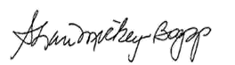
Shari Mickey-Boggs
Senior Associate Chancellor for Human Resources

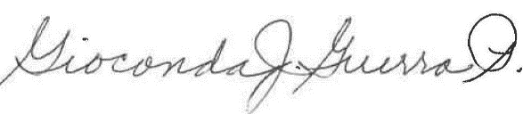

Gioconda Guerra Pérez
Executive Associate Vice Chancellor for Diversity

